What is JDK,JRE,JVM

What are the other ways to create an object other than creating as new object?

Explain java.lang.OutOfMemoryError

Is JVM, a compiler or interpreter ?

Difference between loadClass and Class.forName ?

Should we override finalize method ?

Which kind of memory is used for storing object member variables and function local variables ?  
 Why do member variables have default values whereas local variables don't have any default value ?

Why Java don't use pointers ?

What are various types of Class loaders used by JVM ?

How are classes loaded by JVM ?

Which memory areas does instance and static variables use ?

What is PermGen or Permanent Generation ?

What is metaspace ?

Describe what happens when an object is created in Java.

Different types of memory used by JVM ?

Why a static block executes before the main method ?

Can we override static method ?

Why we cannot override static method ?

Why use this keyword

When Need of super keyword ?

What is the difference between this. (this dot) and this() (this off).

Difference between static and final keyword

why main method is static ?

Difference between non-static and static variable ?

What is difference between super and this keyword

Does Java Pass by Value or Pass by Reference

What is a Constructor?

Do we have Copy Constructor in Java?

What is Constructor Chaining ?

Can we call sub class constructor from super class constructor?

What is No-arg constructor?

How a no – argument constructor is different from default Constructor?

What are private constructors and where are they used?

When do we need Constructor Overloading?

Do we have destructors in Java?

What are native methods?

Can we override static method in Java?

Can we overload a static method in Java?

Can we override a private method in Java?

What is method hiding in Java?

Q) Lab work:

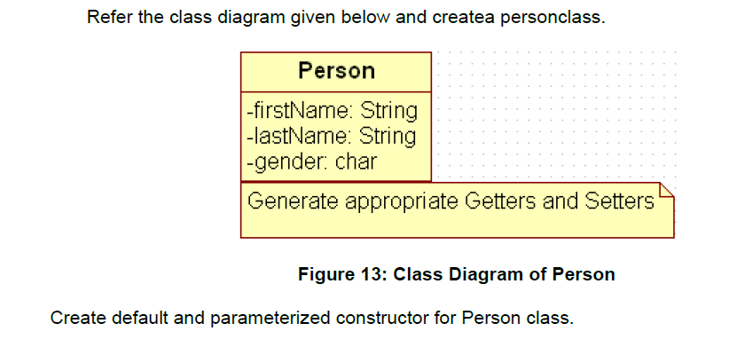

Also Create “PersonMain.java” program and write code for following operations:

a) Create an object of Person class and specify person details through constructor.

b): Modify to accept phone number of a person. Create a new method to implement the same and also define method for displaying persondetails.

c): Modify the above program, to accept only ‘M’ or ‘F’ as gender field values. Use Enumeration for implementing the same

--After spring--

d) Add a method called calculateAge which should accept person’s date of birth and calculate age of a person.

e) Add a method called getFullName(String firstName, String lastName) which should return full name of a person

f) Display person details with age and fullname.

.

|  |
| --- |
| Write a program to accept a number from user as a command line argument and check whether the given number is positive or negative number. |
|  |
|  |